

# Session 1

Assignment 1 Question

*Session 1: Assignment 1*

**Table of Contents**

## Introduction

1. Problem Statement
2. Output

### Introduction

This assignment will help you to consolidate the concepts learnt in the session.

1. **Problem Statement**

**Task 1:**

1.

Install Jupyter notebook and run the first program and share the screenshot of the output. LINK

2.

Write a program which will find all such numbers which are divisible by 7 but are not a multiple of 5, between 2000 and 3200 (both included). The numbers obtained should be printed in a comma-separated sequence on a single line.

3.

Write a Python program to accept the user's first and last name and then getting them printed in the the reverse order with a space between first name and last name.

4.

Write a Python program to find the volume of a sphere with diameter 12 cm. Formula: V=4/3 * π * r 3

### Task 2:

1.

Write a program which accepts a sequence of comma-separated numbers from console and generate a list.

2.

Create the below pattern using nested for loop in Python.

*

* *

* * *

* * * *

* * * * *

* * * *

* * *

* *

*

3.

Write a Python program to reverse a word after accepting the input from the user.

**Sample Output:** Input word: AcadGild Output: dilGdacA

4.

Write a Python Program to print the given string in the format specified in the **sample output.**

WE, THE PEOPLE OF INDIA, having solemnly resolved to constitute India into a SOVEREIGN, SOCIALIST, SECULAR, DEMOCRATIC REPUBLIC and to secure to all

its citizens

**Sample Output:**

WE, THE PEOPLE OF INDIA,

having solemnly resolved to constitute India into a SOVEREIGN, !

SOCIALIST, SECULAR, DEMOCRATIC REPUBLIC

and to secure to all its citizens

**NOTE: The solution shared through Github should contain the source code used and the screenshot of the output.**

1. **Output**

**Task 1:**

2.

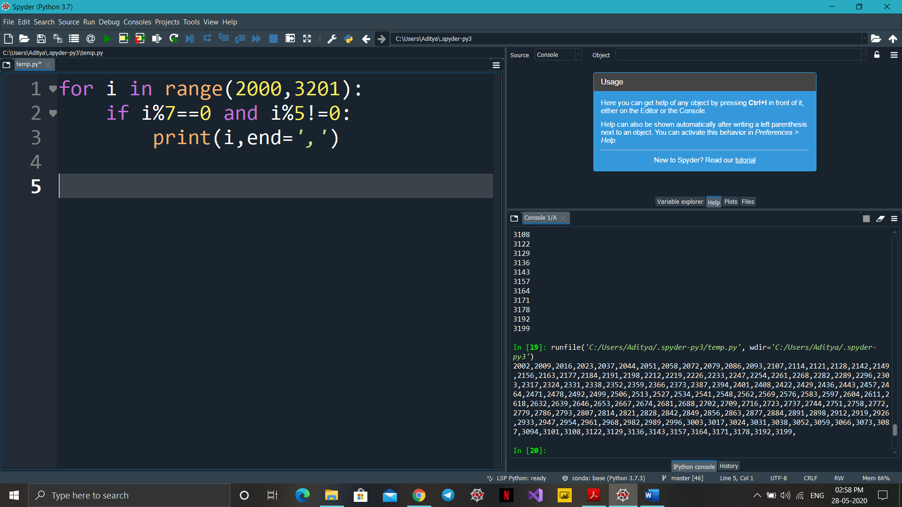

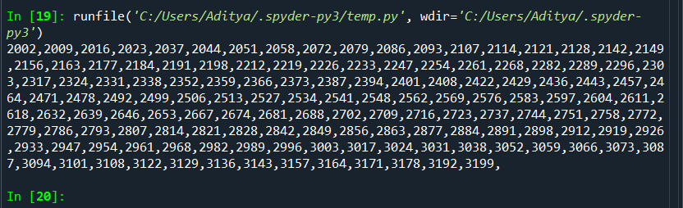

3.

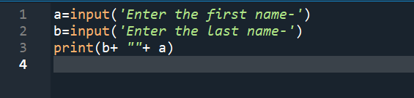

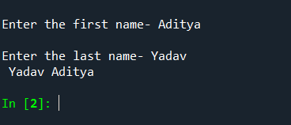

4.

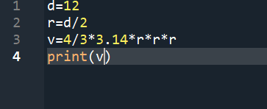

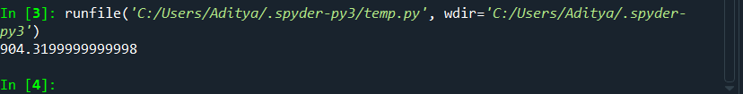

### Task 2:

1.

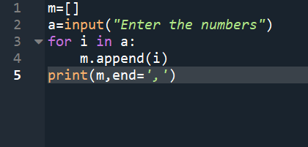

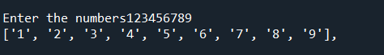

2.

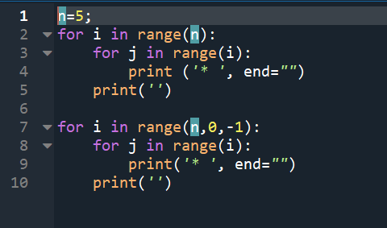

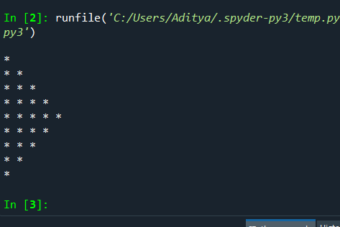

3.

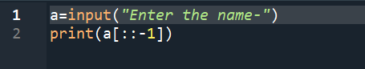

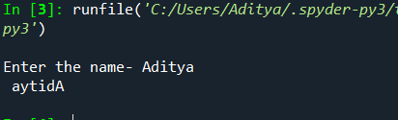

4.

